I have kept dependency. The following code will only run with windows system.

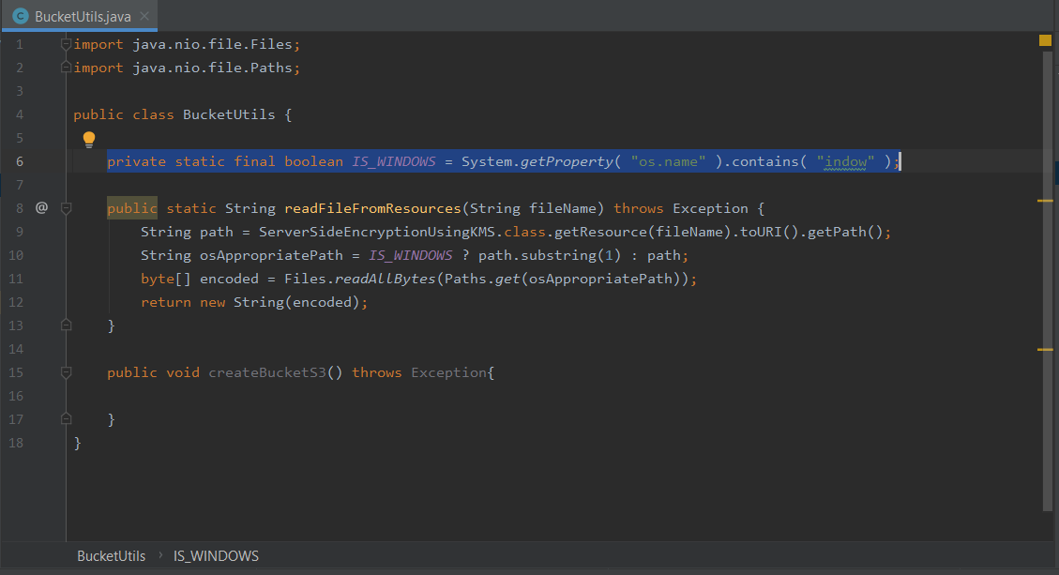

Client-side encryption using JAVA:

<https://aws.amazon.com/articles/client-side-data-encryption-with-the-aws-sdk-for-java-and-amazon-s3/>

Server-side encryption using JAVA:

<https://github.com/mattua/AWSJavaHelloWorld/blob/master/src/main/java/S3JavaSDKExample.java>

<https://www.youtube.com/watch?v=5U8ZMjSK8LQ>

<https://docs.amazonaws.cn/en_us/AmazonS3/latest/dev/s3-dg.pdf> (Page 266)

<https://aws.amazon.com/blogs/security/share-custom-encryption-keys-more-securely-between-accounts-by-using-aws-key-management-service/>

<https://forums.aws.amazon.com/thread.jspa?messageID=333135>

<https://aws.amazon.com/blogs/developer/amazon-s3-encryption-with-aws-key-management-service/>